|  |
| --- |
|  |
| The Documentation |
| [Type the document subtitle] |
|  |
| **[Your Name]** |
| **[Pick the date]** |

[Type the abstract of the document here. The abstract is typically a short summary of the contents of the document. Type the abstract of the document here. The abstract is typically a short summary of the contents of the document.]

Table of Contents

[To update the table of contents, right click the message below and select Update Field (F9 on PC, ⌥⌘U on Mac).]

**No table of contents entries found.**

1. Pages
   1. Page Tree

Home  
 Product  
 Product List  
 Product Detail  
 v1.1-20160825  
 v1.0  
 Project  
 Project Information  
 Add Comment  
 Comment Detail  
 Price List  
 Price List Factory  
 Create by copy  
 v1.1-20160825  
 v1.0  
 Price List Zone  
 Create by copy  
 v1.1-20160825  
 v1.0  
 Create  
 Admin  
 Contract  
 v1.0  
 Order  
 Order List  
 Main Page  
 Factory View  
 Detail Page  
 Factory View (TODO)  
 v1.0  
 Zone View  
 Agent View  
 Add New Order  
 Main Page  
 v1.0  
Tab control  
Finished pages  
 Tab control (finished)

* 1. Home
  2. Product
  3. Product List
  4. Product Detail
  5. v1.1-20160825
     1. User Interface

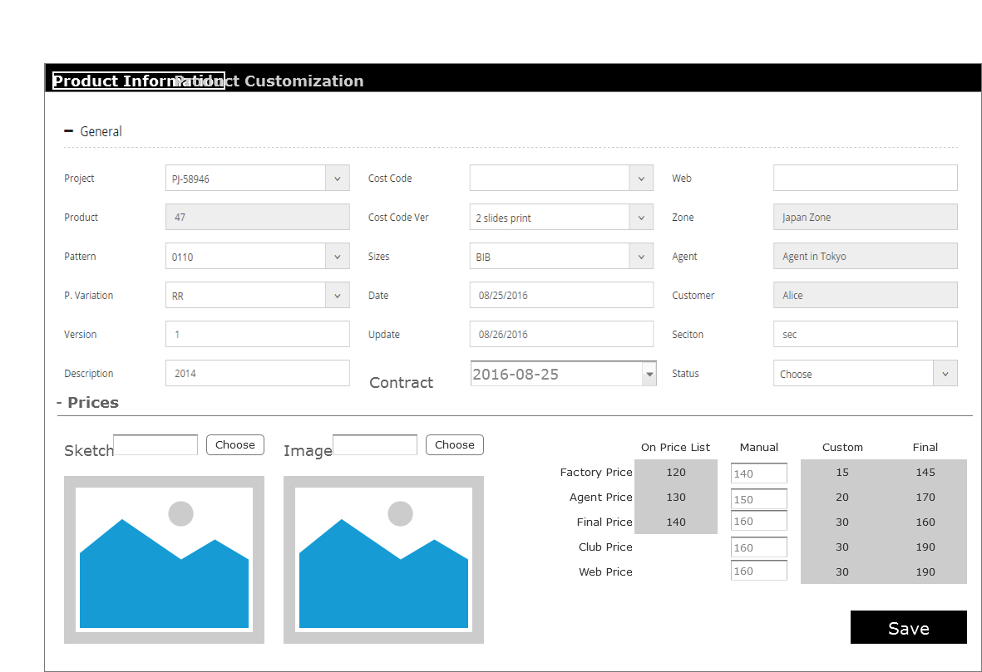

* 1. v1.0
  2. Project
  3. Project Information
     1. User Interface

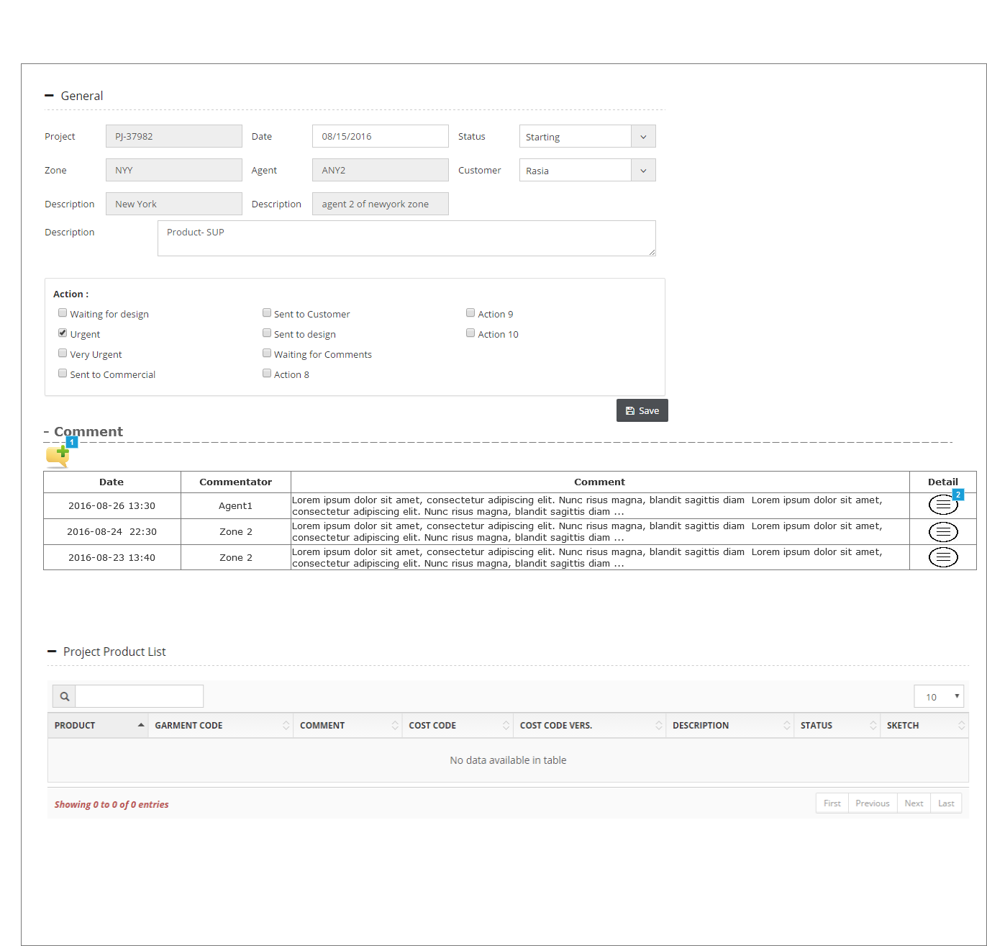

* + 1. Widget Table

| Footnote | Interactions |
| --- | --- |
| 1 | OnClick:  Case 1:  Open Add Comment in Popup Window |
| 2 | OnClick:  Case 1:  Open Comment Detail in Popup Window |

* 1. Add Comment
     1. User Interface

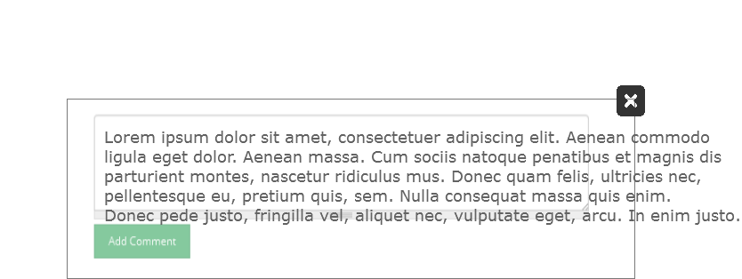

* 1. Comment Detail
     1. User Interface

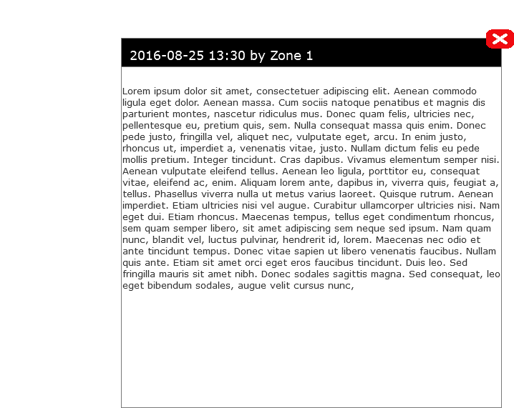

* 1. Price List
  2. Price List Factory
  3. Create by copy
  4. v1.1-20160825
     1. User Interface

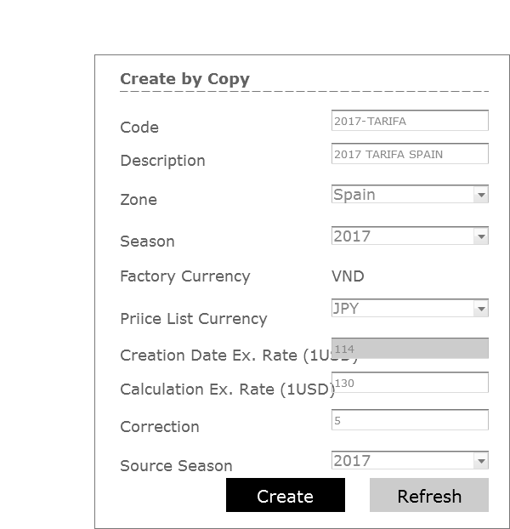

* 1. v1.0
     1. User Interface

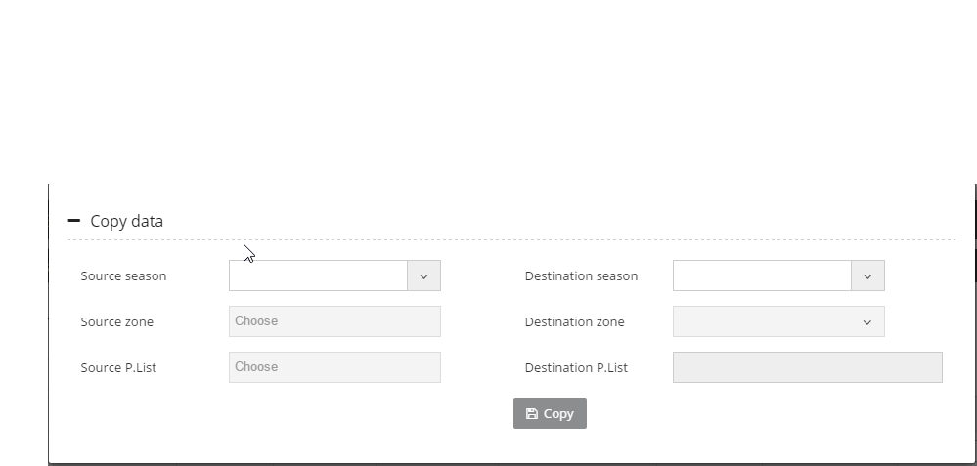

* 1. Price List Zone
  2. Create by copy
  3. v1.1-20160825
     1. User Interface

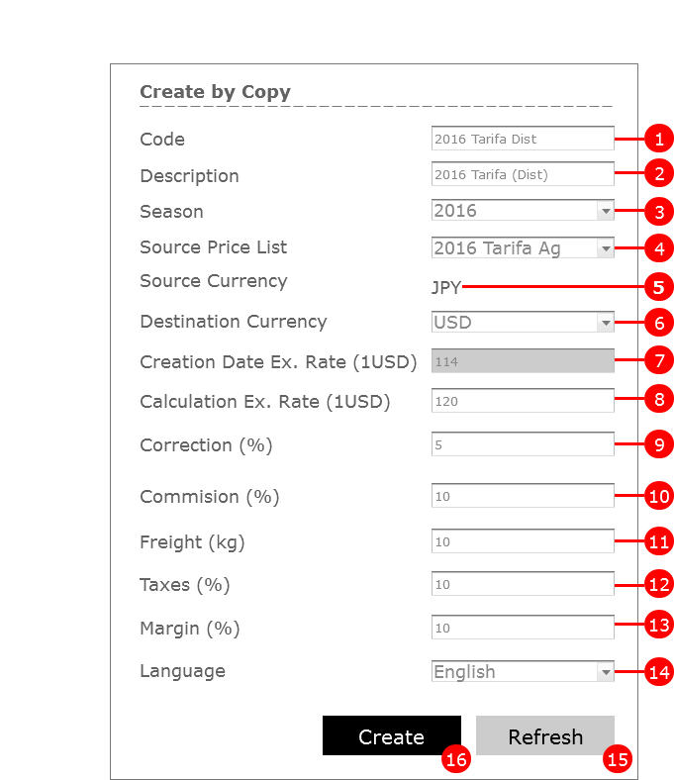

* 1. v1.0
     1. User Interface

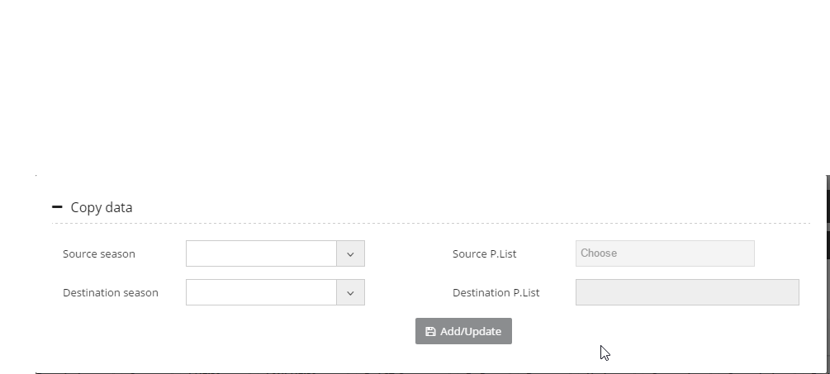

* 1. Create
  2. Admin
  3. Contract
  4. v1.0
     1. User Interface

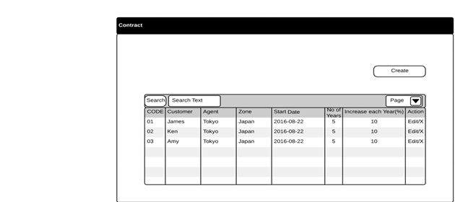

* 1. Order
  2. Order List
  3. Main Page
  4. Factory View
     1. User Interface

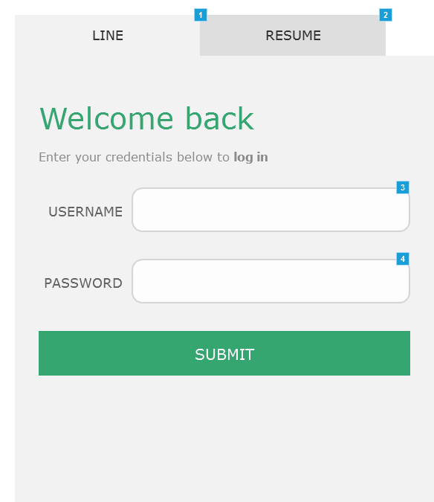

* + 1. Widget Table

| Footnote | Name | Interactions |
| --- | --- | --- |
| 1 | Tab 1 | OnClick:  Case 2:  Set (Dynamic Panel) to State  Set is selected of This equal to "true" |
| 2 | Tab 2 | OnClick:  Case 1:  Set (Dynamic Panel) to State2  Set is selected of This equal to "true" |
| 3 |  | OnFocus:  Case 1:  Set is selected of username equal to "true" OnLostFocus:  Case 1:  Set is selected of username equal to "false" |
| 4 |  | OnFocus:  Case 1:  Set is selected of password equal to "true" OnLostFocus:  Case 1:  Set is selected of password equal to "false" |

* + 1. Unnamed
       1. State2
       2. User Interface

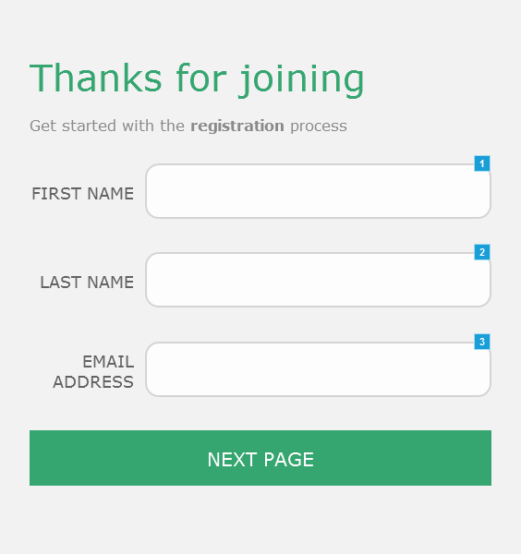

* + - 1. Widget Table

| Footnote | Name | Interactions |
| --- | --- | --- |
| 1 |  | OnFocus:  Case 1:  Set is selected of username equal to "true" OnLostFocus:  Case 1:  Set is selected of username equal to "false" |
| 2 |  | OnFocus:  Case 1:  Set is selected of password equal to "true" OnLostFocus:  Case 1:  Set is selected of password equal to "false" |
| 3 |  | OnFocus:  Case 1:  Set is selected of password equal to "true" OnLostFocus:  Case 1:  Set is selected of password equal to "false" |

* 1. Detail Page
  2. Factory View (TODO)
  3. v1.0
     1. User Interface



* + 1. Widget Table

| Footnote | Name | Interactions |
| --- | --- | --- |
| 1 | Tab 1 | OnClick:  Case 2:  Set (Dynamic Panel) to State  Set is selected of This equal to "true" |
| 2 | Tab 2 | OnClick:  Case 1:  Set (Dynamic Panel) to State2  Set is selected of This equal to "true" |
| 3 |  | OnFocus:  Case 1:  Set is selected of username equal to "true" OnLostFocus:  Case 1:  Set is selected of username equal to "false" |
| 4 |  | OnFocus:  Case 1:  Set is selected of password equal to "true" OnLostFocus:  Case 1:  Set is selected of password equal to "false" |

* + 1. Unnamed
       1. State2
       2. User Interface



* + - 1. Widget Table

| Footnote | Name | Interactions |
| --- | --- | --- |
| 1 |  | OnFocus:  Case 1:  Set is selected of username equal to "true" OnLostFocus:  Case 1:  Set is selected of username equal to "false" |
| 2 |  | OnFocus:  Case 1:  Set is selected of password equal to "true" OnLostFocus:  Case 1:  Set is selected of password equal to "false" |
| 3 |  | OnFocus:  Case 1:  Set is selected of password equal to "true" OnLostFocus:  Case 1:  Set is selected of password equal to "false" |

* 1. Zone View
     1. User Interface



* + 1. Widget Table

| Footnote | Name | Interactions |
| --- | --- | --- |
| 1 | Tab 1 | OnClick:  Case 2:  Set (Dynamic Panel) to State  Set is selected of This equal to "true" |
| 2 | Tab 2 | OnClick:  Case 1:  Set (Dynamic Panel) to State2  Set is selected of This equal to "true" |
| 3 |  | OnFocus:  Case 1:  Set is selected of username equal to "true" OnLostFocus:  Case 1:  Set is selected of username equal to "false" |
| 4 |  | OnFocus:  Case 1:  Set is selected of password equal to "true" OnLostFocus:  Case 1:  Set is selected of password equal to "false" |

* + 1. Unnamed
       1. State2
       2. User Interface



* + - 1. Widget Table

| Footnote | Name | Interactions |
| --- | --- | --- |
| 1 |  | OnFocus:  Case 1:  Set is selected of username equal to "true" OnLostFocus:  Case 1:  Set is selected of username equal to "false" |
| 2 |  | OnFocus:  Case 1:  Set is selected of password equal to "true" OnLostFocus:  Case 1:  Set is selected of password equal to "false" |
| 3 |  | OnFocus:  Case 1:  Set is selected of password equal to "true" OnLostFocus:  Case 1:  Set is selected of password equal to "false" |

* 1. Agent View
     1. User Interface



* + 1. Widget Table

| Footnote | Name | Interactions |
| --- | --- | --- |
| 1 | Tab 1 | OnClick:  Case 2:  Set (Dynamic Panel) to State  Set is selected of This equal to "true" |
| 2 | Tab 2 | OnClick:  Case 1:  Set (Dynamic Panel) to State2  Set is selected of This equal to "true" |
| 3 |  | OnFocus:  Case 1:  Set is selected of username equal to "true" OnLostFocus:  Case 1:  Set is selected of username equal to "false" |
| 4 |  | OnFocus:  Case 1:  Set is selected of password equal to "true" OnLostFocus:  Case 1:  Set is selected of password equal to "false" |

* + 1. Unnamed
       1. State2
       2. User Interface



* + - 1. Widget Table

| Footnote | Name | Interactions |
| --- | --- | --- |
| 1 |  | OnFocus:  Case 1:  Set is selected of username equal to "true" OnLostFocus:  Case 1:  Set is selected of username equal to "false" |
| 2 |  | OnFocus:  Case 1:  Set is selected of password equal to "true" OnLostFocus:  Case 1:  Set is selected of password equal to "false" |
| 3 |  | OnFocus:  Case 1:  Set is selected of password equal to "true" OnLostFocus:  Case 1:  Set is selected of password equal to "false" |

* 1. Add New Order
  2. Main Page
  3. v1.0
     1. User Interface

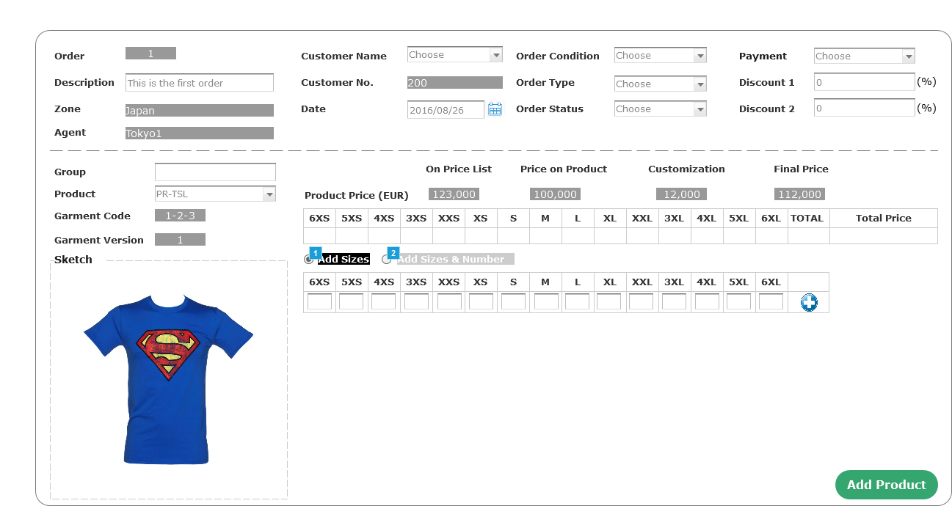

* + 1. Widget Table

| Footnote | Name | Interactions |
| --- | --- | --- |
| 1 | rdSize | OnSelected:  Case 1:  Enable lblSize, panelAddSize  Disable lblSizeNumber, panelSateSizeNumber  Set (Dynamic Panel) to State1, panelSateSizeNumber to StateSzie |
| 2 | rdSizeNumber | OnSelected:  Case 1:  Enable lblSizeNumber, panelSateSizeNumber  Disable lblSize, panelAddSize  Set (Dynamic Panel) to State2  Set is selected of This equal to "true" |

* + 1. Unnamed
       1. State1
       2. User Interface



* + - 1. State2
      2. User Interface

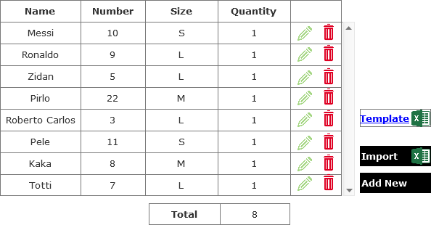

* + 1. panelSateSizeNumber
       1. StateSzie
       2. User Interface



* + - 1. StateSizeNumber
      2. User Interface

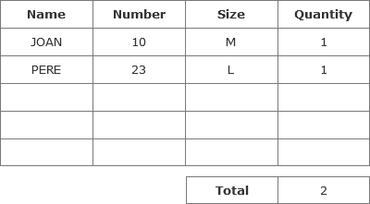

* + 1. Unnamed
       1. State1
       2. User Interface



* 1. Tab control
     1. User Interface

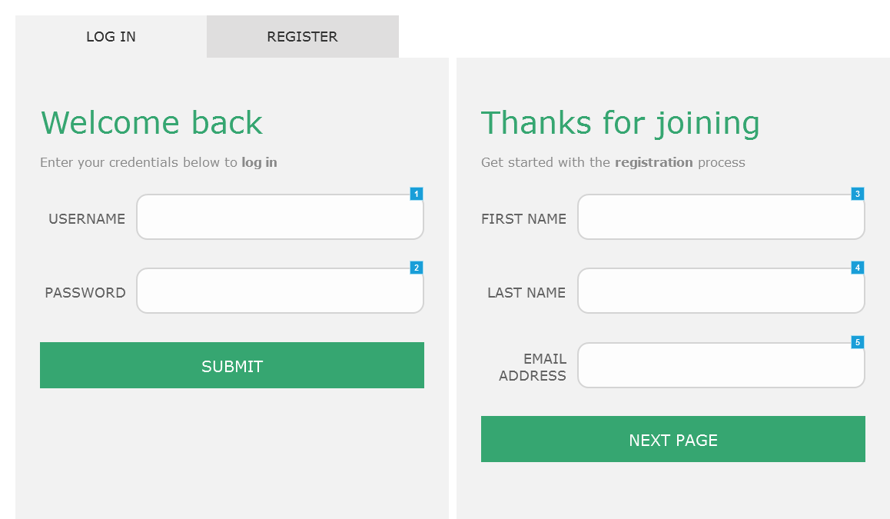

* + 1. Widget Table

| Footnote | Name | Interactions |
| --- | --- | --- |
| 1 |  | OnFocus:  Case 1:  Set is selected of username equal to "true" OnLostFocus:  Case 1:  Set is selected of username equal to "false" |
| 2 |  | OnFocus:  Case 1:  Set is selected of password equal to "true" OnLostFocus:  Case 1:  Set is selected of password equal to "false" |
| 3 |  | OnFocus:  Case 1:  Set is selected of username equal to "true" OnLostFocus:  Case 1:  Set is selected of username equal to "false" |
| 4 |  | OnFocus:  Case 1:  Set is selected of password equal to "true" OnLostFocus:  Case 1:  Set is selected of password equal to "false" |
| 5 |  | OnFocus:  Case 1:  Set is selected of password equal to "true" OnLostFocus:  Case 1:  Set is selected of password equal to "false" |

* 1. Tab control (finished)
     1. User Interface

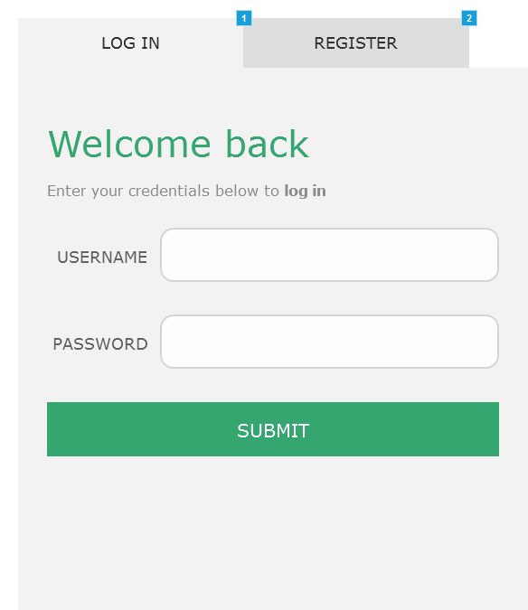

* + 1. Widget Table

| Footnote | Name | Interactions |
| --- | --- | --- |
| 1 | Tab 1 | OnClick:  Case 1:  Set (Dynamic Panel) to State1  Set is selected of This equal to "true" |
| 2 | Tab 2 | OnClick:  Case 1:  Set (Dynamic Panel) to State2  Set is selected of This equal to "true" |

* + 1. Unnamed
       1. State1
       2. User Interface

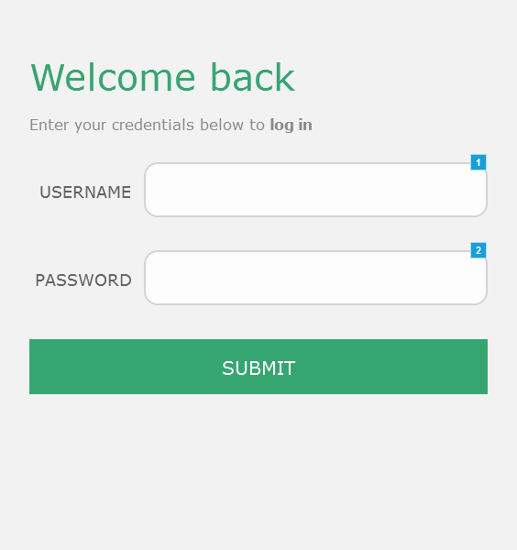

* + - 1. Widget Table

| Footnote | Name | Interactions |
| --- | --- | --- |
| 1 |  | OnFocus:  Case 1:  Set is selected of Username equal to "true" OnLostFocus:  Case 1:  Set is selected of Username equal to "false" |
| 2 |  | OnFocus:  Case 1:  Set is selected of Password equal to "true" OnLostFocus:  Case 1:  Set is selected of Password equal to "false" |

* + - 1. State2
      2. User Interface

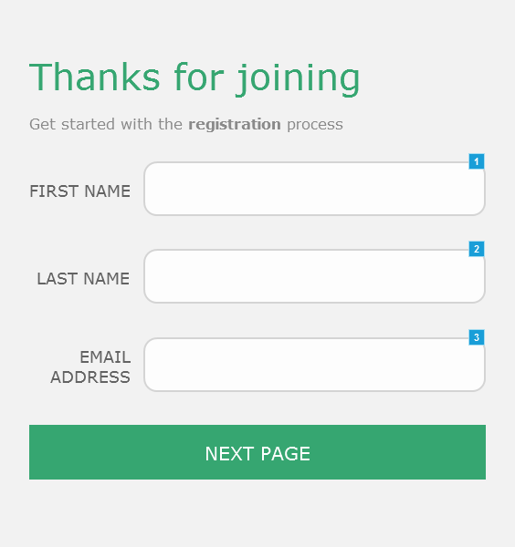

* + - 1. Widget Table

| Footnote | Name | Interactions |
| --- | --- | --- |
| 1 |  | OnFocus:  Case 1:  Set is selected of First name equal to "true" OnLostFocus:  Case 1:  Set is selected of First name equal to "false" |
| 2 |  | OnFocus:  Case 1:  Set is selected of Last name equal to "true" OnLostFocus:  Case 1:  Set is selected of Last name equal to "false" |
| 3 |  | OnFocus:  Case 1:  Set is selected of Email address equal to "true" OnLostFocus:  Case 1:  Set is selected of Email address equal to "false" |

1. Masters
   1. Master List

Header logo  
Header (finished)  
radio

* 1. Header logo
     1. User Interface



* 1. Header (finished)
     1. User Interface



* + 1. Unnamed
       1. State1
       2. User Interface



* + - 1. Widget Table

| Footnote | Name | Interactions |
| --- | --- | --- |
| 1 | Home | OnClick:  Case 1:  Open Link in Current Window |
| 2 | Manage | OnClick:  Case 1:  Open Link in Current Window |
| 3 | Profile | OnClick:  Case 1:  Open Link in Current Window |
| 4 | Help | OnClick:  Case 1:  Open Link in Current Window |

* 1. radio
     1. User Interface

